Task 1 可用的词汇
To make the matter worse, .
Not only that, .

Task 1 多用一些连接词，signpost，

It will be of great help

As soon as possible

Happy 可以用的替换词 delighted, ecstatic

Conjunctions

Coordinating conjunctions

There are seven coordinating conjunctions in English, and you can remember them using the mnemonic device FANBOYS: for, and, nor, but, or, yet, so.

这种一般是用来连接两个独立的句子的

Subordinating conjunctions
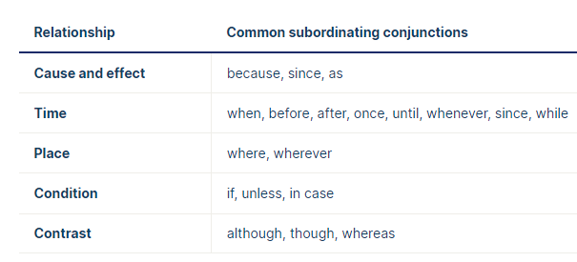

Correlative conjunctions
This type of conjunction always comes in a pair and is used to join grammatically equal elements in a sentence. Common pairs include either … or, neither … nor, not only … but also, and both … and. In most cases, no comma should be used between the two elements

